

Hi I am Swapnil Rane from India. Thanks for purchasing the asset.

For any query fell free to contact me

:- [madfireongames@gmail.com](mailto:madfireongames@gmail.com)

Introduction

In this project you will learn object pooling , saving data on device , importance of tag and many more important concepts.

Directories

Animation folder contains animations.

Prefab folder contain object to we used in scene.

Scene folder contains scenes.

Scripts contain scripts and sprite folder contain sprites.

Managers

Managers are used to manage the game objects.

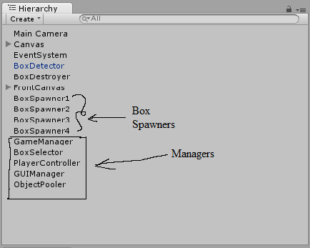

PlayerController is not a manager , it keep track of player inputs

Game Detail

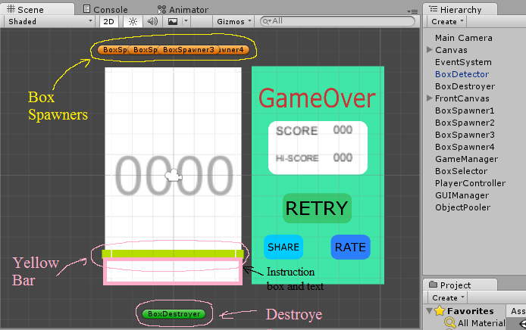

Box spawner : From where boxes are spawn.

Destroyer : It deactivates boxes.

Yellow Bar : check for the required box.

Instruction box and text: this changes with respective box colour.

Scene Order

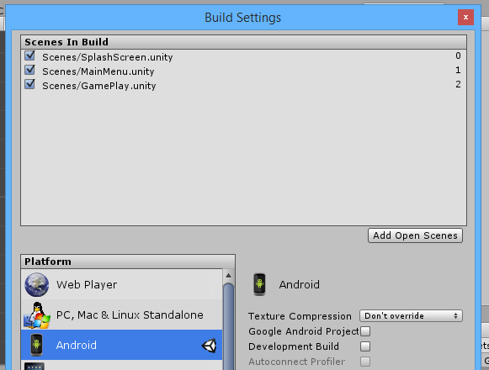

To run game please arrange scene as shown in image.

Main Menu

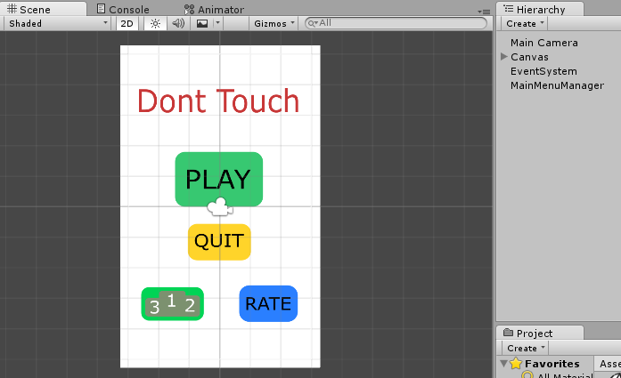

Important Methods

Singleton :- This method ensures that we don’t have 2 game object in a same scene. For example : while testing we created a gameManager object which manages the game and we assign it to every scene , then when we go from one scene to another the singleton make sure that the gameobject which was 1st created remains and others get destroyed. Singleton also help us to get reference to the variable of that script from other scripts.In it we don’t have to assign the gameobject having that script in the inspector or find it by tag.

Instance: Its similar to the singleton but the difference is the object is not assigned in every scene and only available is one scene , like the shop manager in shop scene etc.

Again thanks for purchasing this asset